Baltic SCOPE topic – Shipping (paper 2.0 Stockholm JUNE 2015)

Initial conclusion and recommendation

Marine Spatial Planning (MSP) is a process that brings together multiple users of marine areas, including shipping, offshore energy, aquaculture, fishing, conservation and recreation and industry to make informed, co-ordinated decisions about how to use marine resources sustainably and reduce user conflicts. MSP has its origins in marine ecological and environmental protection, but has evolved to encompass economic and navigational safety concerns.

Main elements of the MSP process and the specific navigational concerns are to be considered when assessing the impact on existing marine traffic routing and navigational safety caused by offshore developments. It is important that preparation and planning takes place to ensure that safety at sea and navigation requirements are adequately addressed.

- The future planning in the SWC (South West Baltic Case) must respect UNCLOS regulation including the strait regime in the Sound and the approaches to the Great Belt (transboundary issue).

- It is recommended not to make rerouting in and/or adjacent to existing Traffic Separation Schemes (TSSs) (transboundary issue).

- It is recommended to avoid rerouting of existing main routes. Main routes mean recommended routes (DW Route T) as well as transit traffic flow in connection with TSSs through the area (transboundary issue).

- It is recommended to establish a safety distance to fairways, routes, TSSs and marking of offshore facilities i.a.w. NTI MSP recommendation and IALA O-139 (transboundary issue).

- The assessment of the risk of major hazards must be in accordance with Guideline 1018 and follow recognised risk assessment methods, e.g. the IALA risk management toolbox or the IMO adopted Formal Safety Assessment methodology (FSA).

- Consideration must be paid to the separation of sea traffic if there is conflict between commercial vessels and leisure craft, e.g. the above-mentioned safety distance must include space for leisure craft (transboundary issue).

Background (Shipping)

For many millennia, shipping has been present in the Baltic Sea and, over the last 10 years, it has become one of the themes that is under pressure from other activities, especially areas with many constructions like Offshore Wind Farms (OWF).

The Baltic area consists of highly and increasingly trafficked waterways, connecting large ports around the Baltic. The waterways are used by a large number of cargo ships, oil and chemical tankers, container ships, cruise ships, etc. to transport goods and passengers to the Baltic Sea from other parts of Europe and overseas destinations. Furthermore, ferries with frequent daily departures transport passengers between the countries bordering the Baltic Sea. Finally, an increasingly large number of leisure craft (sports and tourism) use the area during the summer season.

In the project area of the SWC, shipping is seen as accumulating in the western part, splitting up into more routes and traffic flows north through the Sound and west through the western part of the Baltic Sea between Denmark and Germany. The latter route is subdivided into a route through the Great Belt (IMO Route T) and a route to the Kiel Canal (German: Nord-Ostsee Kanal).

The seabed is very delicate with many grounds and draught limitations. In addition, shipping has to deal with rough weather conditions, storms and hurricanes during the autumn and winter seasons, strong currents in the straits and sometimes icy waters during the winter season.

The above brief description of the theme shipping gives an impression of the importance on the future planning of shipping in relation to new sectors and activities. The sector is, at the same time, seen as very important for the entire development of the region, and the challenges, transboundary as well as regional, consist in continuing to maintain sufficient room for manoeuvring so that ships are still able to navigate safely through the area.

Shipping – Analysis SWC

International regulation of shipping in the project area SWC:

UNCLOS:

The legal situation of shipping is influenced to a great extent by international regulations. These include in particular UNCLOS in which the freedom of navigation is guaranteed under Art. 58. Art. 60 para. 7 UNCLOS also states that artificial islands, installations and structures and the surrounding safety zones may not be established where they may cause interference with the use of sea lanes that are recognised and important for international shipping.

According to the Copenhagen Convention of 1857 and, more recently, to United Nations Convention on the Law of the Sea (UNCLOS), Denmark is obliged to ensure harmless or innocent passage for all ships passing through the straits (the Sound (Danish side), Great Belt and Little Belt). At the same time, we are obliged to make pilotage available, though it is not mandatory for transit.

Link to more information on the UNCLOS transit passage regime

International Maritime Organization (IMO):

- The IMO SOLAS Convention, chapter V, "Safety of navigation"
- Ships' routeing (Guidelines), SOLAS regulation 10 (General Provisions on Ships' Routeing (GPSR))
- Guidelines for Formal Safety Assessment (FSA) for use in the IMO rule-making process
- Proposed amendments to resolution A.572(14) (GPSR)

The high intensity of various types of ship traffic in combination with the relatively narrow navigation routes in some parts of the area give rise to critical situations every year.

To ensure the safety of large vessels in accordance with chapter V of the SOLAS Convention on "Safety of navigation", a number of Traffic Separation Schemes (TSSs) and recommended (DW) routes have been established within the project area. All TSSs and the Route T in the SWC have been adopted and approved by the IMO member States (GPSR):
- TSS "In the Sound" between Elsinore and Helsingborg (joint Danish and Swedish TSS)
- TSS "Off Falsterbo" (roundabout, joint Danish and Swedish)
- TSS "S of Gedser" (joint Danish and German)
- TSS "North of Rügen"
- TSS "Bornholmsgat" (joint Danish and Swedish)
- TSS "Adlergrund"
- TSS "Slupska Bank"
- TSS "On the approaches to the Polish Ports in the Gulf of Gdansk"
Other hot spot areas:
Channels and DW routes:
- Drogden Channel (narrow channel off Copenhagen, with a width of approximately 350 metres between the lateral buoys)
- Flinterenden (narrow channel under the Sound bridge off Malmö)
- Upcoming fixed link (tunnel) at the Fehmarn Belt
- Deep water routes through the area from NE to SW.

Ships' routeing systems contribute to safety of life at sea, safety and efficiency of navigation and/or protection of the marine environment. Ships' routeing systems are recommended for use by, and may be made mandatory for, all ships, certain categories of ships or ships carrying certain cargoes, when adopted and implemented in accordance with the guidelines and criteria developed by the IMO.
The TSSs and ships' routeing systems contribute to avoid collisions and groundings.
The IMO's responsibility for ships' routeing is enshrined in SOLAS chapter V, which recognizes the Organization as the only international body for establishing such systems.
TSSs are often found in connection with the narrowing and bending of the routes (traffic flow), i.e. areas that are highly difficulty to navigate.

The main transit (recommended) route between the Skaw and the area northeast of Gedser within the project area is named “Route T”. The maximum obtainable depth in most parts of Route T is 17 metres. However, in the area around Gedser in the south of Route T, the maximum obtainable depth has been reduced to 16.4 metres due to sand migration. In some places along the route, Route T has been split into two routes, one of which is for deep draught vessels, which means that the route is only for passing ships with a draught of more than 10 metres.

This map shows all the traffic (AIS) in 2014 with routes and TSSs. Passage line counts are noted for selected areas:
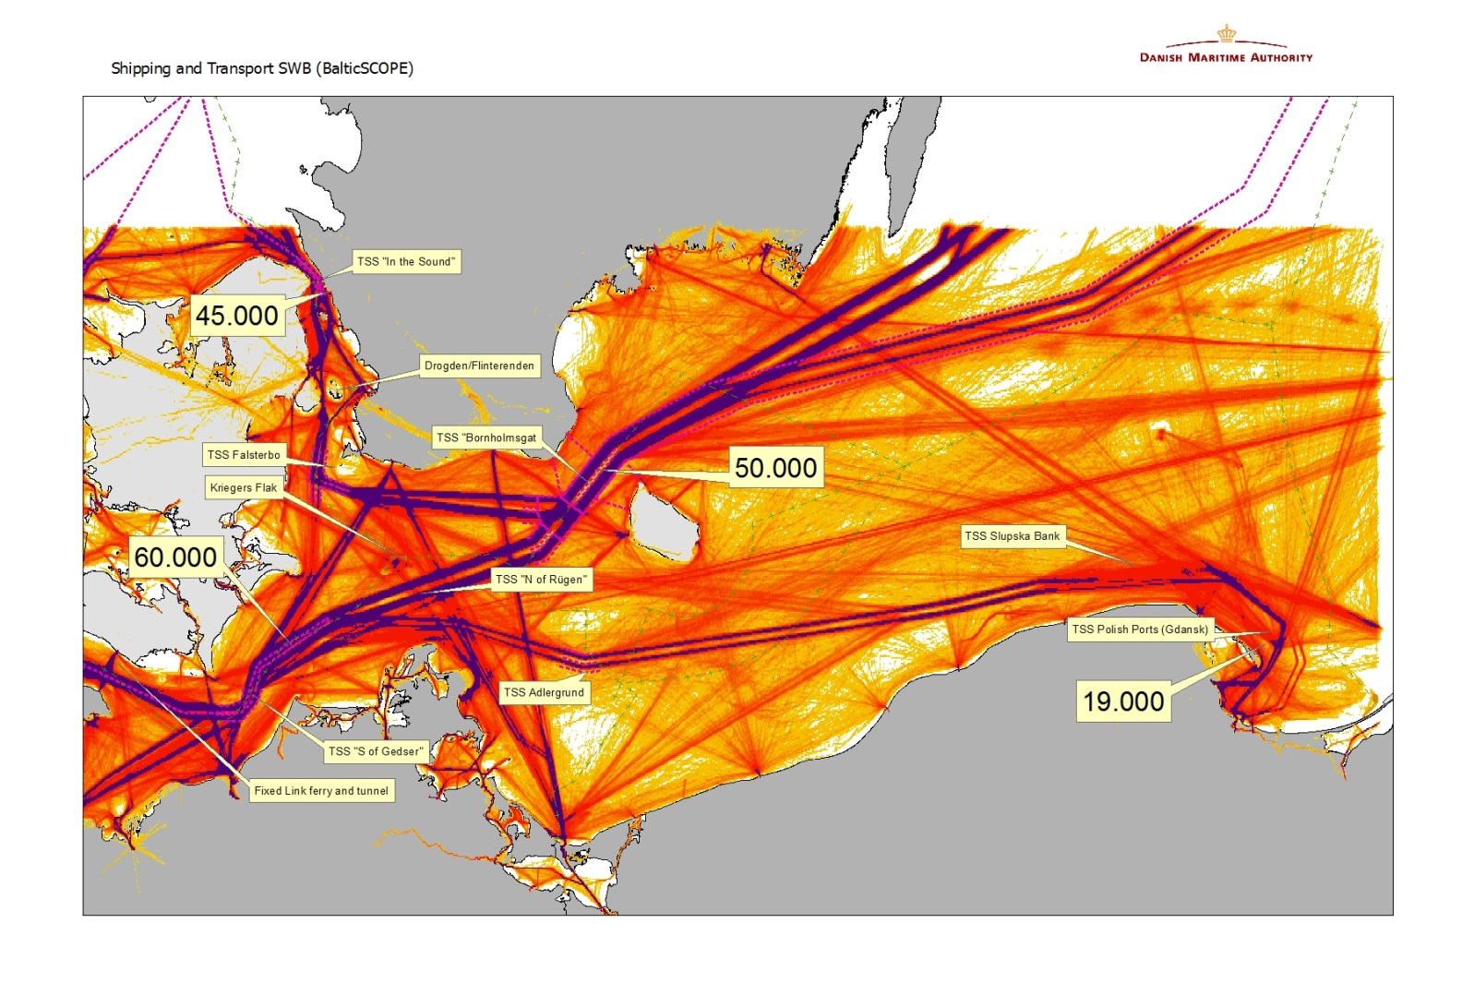

It is important to recognize that the GPSR was developed at a time when large concentrations of multiple objects at sea, such as wind farms, did not exist. These multiple objects could pose a significant risk to maritime safety as shipping traffic continues to grow. In congested areas in particular, large concentrations of objects at sea, such as wind farms, may entail additional risks to navigation in comparison with single objects at sea. When planning for shipping in the area, these planned routes should, as closely as possible, follow the existing patterns of traffic flow in the area as determined by traffic surveys (AIS data).

As ships' size and the traffic density increase, the ability of vessels to act according to the International Regulations for Preventing Collisions at Sea, 1972, as amended (COLREG), becomes more and more challenging, in particular when the available manoeuvring space decreases due to the development of large concentrations of objects at sea.

At present, the IMO GPSR does not provide guidelines on how to deal with such large concentrations of objects related to established or new routeing measures.

A proposed draft amendment to the GPSR has been submitted to the 95th session of the MSC:

Some extracts from the proposed amendment:
It should be recognized that concentrations of multiple structures have a different impact on the ability of vessels to act according to the COLREG, compared to single objects such as e.g. drilling rigs (MODUs), exploration platforms and other similar structures.

The GPSR provides guidelines for the establishment of such single objects, but not for multiple structures.

Additional risks to the safety of navigation related to the establishment of multiple structures are, amongst others:

- the difficulty of detecting vessels sailing within such an area containing multiple structures, and leaving such an area, while those vessels may still have right of way in a crossing situation as per rule 15 of COLREG; and,
- the effect of such an area containing multiple structures on vessel radar systems.

The benefits of the above-mentioned factors are:

- awareness of the additional risks that may be created by multiple structures at sea, as compared to single objects; and

- the safeguarding of sufficient manoeuvring space for ships in the vicinity of multiple structures at sea, and as such the safeguarding of safety of navigation.
The proposed amendment text is as follows:
"3.13bis In planning to establish multiple structures at sea, such as extensive concentrations of wind turbines, Governments should take into account, as far as practicable, the impact these could have on the safety of navigation. Traffic density and prognoses, the presence or establishment of routeing measures in the area, the manoeuvrability of ships, and their obligations under the International Regulations for Preventing Collisions at Sea, 1972, as amended should be considered when planning to establish multiple structures at sea."

IALA (International Association of Lighthouse Authorities):
Recommendations and guidelines related to MSP and shipping:

IALA Maritime Buoyage System (MBS)

IALA Recommendation O-139, Marking of Man-made offshore structures

IALA Guideline 1018, methods for risk assessment, the IALA risk management toolbox (IWRAP)

IALA Draft Guideline on Navigational Safety within Maritime Spatial Planning under way:

Describes the main elements of the MSP process and the specific navigational concerns to be considered when assessing the impact on existing marine traffic routing and navigational safety caused by offshore developments.
Other papers of importance:
The Shipping Industry and Marine Spatial Planning by The Nautical Institute (NTI)

An operational (main) guide to the risks and benefits connected with the shipping industry that should be considered during the MSP process. Developed in association with IALA.

National input regarding guidelines and issues for planning of shipping in relation to other activities:
Sweden:

Below you will find comments on the questions asked with regard to marine spatial planning within Swedish waters.

- To the extent that they are available, your guidelines, considerations and requirements on the planning of shipping (how is the space defined) in relation to your national MSP especially in relation safety of navigation.
-------------
Today there are no formal MSP implemented in Sweden. However the national legislation is under construction and all parties involved in the Swedish MSP has collected and submitted data and information for a draft map of the present situation.
With regard to shipping the aim has mainly focused on how to make shipping routes safer in order to reduce accidents such as collisions and groundings.
This work has mainly been done by analysing AIS data and then constructing recommended shipping routes. These recommended routes are then complemented by traffic separation schemes adopted by IMO in places where it has been found necessary/suitable. Work has also been done to designate main shipping routes in Swedish waters. For the transit traffic in the Baltic Sea Sweden has together with the other HELCOM countries also been working on strengthening the surveys of shipping routes and taking action to enhance the safety of navigation.

- Guidelines, etc. in connection with the planning of offshore wind farms (OWF) and other similar offshore constructions (wave, oil and aqua cultural) next to shipping routes
----------
In 2009 the SMA and STA together made a guideline for establishing of offshore windfarms along the Swedish coast. This guideline is focusing on risk assessment and based on the results of risk assessment each individual windfarm can have different safety levels (safety distances).
There are no formal minimum distances given within the guideline. Until now safety distances have been dealt with locally depending on traffic situation and other risks.

The guideline is written in Swedish and can be found at the link below:
https://www.transportstyrelsen.se/globalassets/global/sjofart/dokument/vagledning_vid_proj_o_riskanalys_av_vindkraftverksetabl_svenska_kusten.pdf

In Sweden there are no offshore oil installations as per of today. With regard to other activities such as wave power and agriculture there are no specific rules or guidelines available.

- Are you at present aware of conflicting issues/ synergetic issues e.g. rerouting of main traffic flow due to present or future planning of multiple offshore obstructions (OWF) both national and international?
-------------
International
Krieger’s Flak between Sweden, Denmark, and Germany is an example where conflicts between shipping and OWF may occur. SMA and the STA are still concerned regarding the cumulative effects if all three countries will go ahead and build as planned. Today the designated shipping route, pointed out in Sweden between Trelleborg and Travemunde ends up in the OWF at the boarder of the EEC which forces the ship traffic to take other routes.

National
Blekinge Offshore is the so far largest OWF project in Sweden. If permission is given it may be up to 500 windmills. The project will involve rerouting of shipping lanes however this lane has a relatively small density of merchant traffic and therefore probably less effect on accessibility of shipping.

- Your present activities in your area, which installations exist and where, what space is the sector using and where.
-------------
Until today there are about 60 offshore windmills within Swedish waters established within five OWF.
The largest OWF is Lillgrund situated in the southern part of Öresund consisting of 40 windmills.
The safety distance which has been used until now is mainly the 500 metres which are described in UNCLOS.

- Do you see any future conflicts in your area which will have an impact on shipping (routes)? If so will they be bilateral or multilateral.
--------------
More areas may be considered as (environmental) protective areas in the future, subsequently an increased demand for rerouting of international shipping routes may occur. The conflicts may be both national and international.
Lithuania is a country which is implementing MSP and Sweden has raised concerns with regard to Midsjöbankarna and how this area will be used in the future. A study with regard to how future shipping routes may be affected is essential when implementing MSP, also in between countries. As shipping is an international business the cooperation and bilateral work between countries is essential when it comes to MSP. There is a compelling need to sync and adjust our national MSP with other countries MSP especially when it comes to navigation and shipping.

The Swedish Maritime Administration submits above mentioned observations in regard to presented questions from the Danish Maritime Authority for their work within the project “Baltic Scope”.

The comments and information presented in this letter has been coordinated and consulted with the Swedish Transport Agency.

Above mentioned has been handled by the Head of the Infrastructure unit Marielle Svan in participation with the senior nautical adviser at the Infrastructure unit Johan Eriksson, the latter as reporting officer.

Denmark:
In Denmark we have not yet implemented MSP, but in connection with planning of existing and future areas for OWF, we have developed some general guidelines in order to facilitate shipping and OWF without risking the safety of navigation:
- Basically at least 3 NM safety distance from main routes to multiple structures
- Whatever safety distance all identified areas for multiple structures like OWF should undergo a formal assessment of safety of navigation. If areas is known but not the design of the structures (e.g. many small wind mills or fewer big ones) the assessment must be based on worst case scenario. When the design of OWF is known the analysis must be recalculated.
Formal assessment on safety of navigation always requires a hazard identification (Hazid workshop) for the individual OWF taking all stakeholders (pilots, port authorities, local communities, sailing clubs etc.) opinion into account.
- Marking of OWF is based on the IALA Recommendation O-139, Marking of Man-made offshore structures
- As starting point all OWF are free for Navigation in operating phase. Closed in construction phase.
- Some fishing is normally allowed with in OWF but because the cables created cable protection zones there are prohibition against anchoring and fishing with trawl.
- The distance between the sea surface and bottom wing tip must be at least 20 meters compared to HAT (Highest Astronomical Tide).
- Turbine foundations must be designed "collision friendly". No "can-opener effect"
- There must be procedures that can perform emergency stop of one or more turbines at risk of vessel collision with turbines.
For example if national surveillance authorities (rescue centre) discover or reporting on such a risk, then they should be able to contact "operations centre" to stop the turbines.
- There could be additional requirements on security for the individual park.
Poland:
Thematic input paper about Traffic lines in Poland (part of the paper below)

Traffic lines on Polish sea waters can be divided to transit routes and approaching routes leading to Polish harbours.

- Transit routes on Polish sea are mentioned in “BSHC-HELCOM Revised Baltic Sea Harmonized Hydrographic Re-Survey Scheme” (http://www.helcom.fi/Documents/Ministerial2013/Ministerial%20declaration/Adopted_endorsed%20documents/BSHC-HELCOM%20Revised%20BS%20Harmonised%20Hydrographic%20Re-survey%20Scheme.pdf). According to this declaration routes will be re-surveyed by Poland (Polish Navy). These routes are not mandatory (except of TSS) but recommended by Polish and foreign nautical publications. Traffic on these routes is monitored by Polish Maritime Administration using AIS technology. There is a system under construction named Krajowy System Bezpieczeństwa Morskiego – KSMB (National System for Safety of Marine Navigation) which will improve monitoring of shipping (e.g. by radar covering of TSS “Ławica Słupska” (TSS “Slupska Bank”), data transfer between Maritime Offices etc.).
- Approaching routes leading to Polish harbours are fairways with parameters strictly defined in Polish law. Polish Maritime Administration is obligated to maintain these parameters (length, width and depth). Traffic on approaching routes is regulated by law (“Port regulations”) and monitored by Harbour Masters (in Poland – part of Maritime Administration, not port authorities). Approaching channels to main Polish ports (Szczecin, Świnoujście, Gdynia, Gdańsk) are under coverage and supervising of VTS.
The Polish Maritime Administration is about to start of preparations for making Maritime Spatial Plan (MSP). we don’t have any formal guidelines, considerations and requirements on the planning of shipping in relations to offshore installations. We hope, we will work out such a guidelines during a process of MSP creating and agreeing. At this point we are at the phase of gathering expert’s opinions and we also are sure, we can use good experiences of our international partners within “Baltic SCOPE” project and modify these experiences to Polish conditions. There is a forum in Poland created for exchanging opinions between specialists, business and administration – “Foundation for Sustainable Energy”. A task of this foundations is, inter alia, to create guidelines for offshore activities to be helpful both for investors and administration. Effect of the work is publication “Guide to the location determination and environmental impact forecasting procedures for offshore wind farms in Polish maritime areas” which is a conclusion of present regulations and knowledge, and also gives directions to be followed in future planning of offshore installations.

Back to your question: routes declared by Polish Government to HELCOM should be a basis for further planning and other activities at the sea (including offshore installations) cannot interfere with shipping. According to this, although we don’t have the MSP, we determined preliminary areas for Offshore Wind Farms. Investors are obligated put to the Ministry of Infrastructure and Development their applications including IMO Formal Safety Assessment (taking into account existing shipping lanes and TSS) and expert’s report about influence of planning Offshore Wind Farms to safety of survey and exploration of mineral resources in neighbouring areas.

Germany:
- To the extent that they are available, your guidelines, considerations and requirements on the planning of shipping (how is the space defined) in relation to your national MSP especially in relation safety of navigation.

  - Please refer to our MSP for the EEZ of the Baltic Sea (English Version, enclosed in this mail): Chapter 2.1, 3.1, paragraphs in the other chapters referring to marine traffic
- Guidelines, etc. in connection with the planning of offshore wind farms (OWF) and other similar offshore constructions (wave, oil and aqua cultural) next to shipping routes
  - Please refer to our information on wind farms and their impact on navigation on our website (http://www.bsh.de/en/Marine_uses/Industry/Wind_farms/index.jsp) , approval procedures for OWF (http://www.bsh.de/en/Marine_uses/Industry/Wind_farms/Approval_Procedure.jsp) , including risk analyses with regard to collision with ships and design of the turbine, that minimises collision impact, Standard “Design of Offshore Wind Turbines” (from 2007, updated version currently under consultation) http://www.bsh.de/en/Products/Books/Standard/index.jsp
  - Information on rules and regulations regarding cable connections and converter stations for offshore wind please take from our Offshore Grid Plan (in English only available for the North Sea, but main rules are the same, safe the technical choice made in the Baltic Sea for Alternating Current (AC), thus no need for big converter station, but more cables to be laid) http://www.bsh.de/en/Marine_uses/BFO/index.jsp ; German version of the Offshore Grid Plan for the Baltic Sea: http://www.bsh.de/de/Meeresnutzung/BFO/Bundesfachplan_Ostsee.jsp
- Are you at present aware of conflicting issues/ synergetic issues e.g. rerouting of main traffic flow due to present or future planning of multiple offshore obstructions (OWF) both national and international?
  - Not really. There is only one minor ferry connection that will be somewhat affected by construction of wind farms in the region of Adlergrund: Ferry Line Sassnitz/Rügen – Rönne/Bornholm (only late March to late October, 1 – 2 departures/day/direction in summer months, other 1 – 2 departures/day on 3 – 4 days/week redirection might slightly increase travelling time from now 3:20 to 4:00 hrs
- Your present activities in your area, which installations exist and where, what space is the sector using and where.
  - See map enclosed – only one wind farm is in operation at the moment (Baltic 1 in the territorial sea of Mecklenburg-Vorpommern), one more (Baltic 2) is currently under construction and quite well developed, Baltic 2 cables also almost all in place
- Do you see any future conflicts in your area which will have an impact on shipping (routes)? If so will they be bilateral or multilateral.
  - There is the persisting conflict with Poland on the status of the harbour approach and anchorage for the ports of Swinoujscie and Szczecin, (an issue to be solved on high diplomatic level) – with some planning and work going on for dredging to make the ports accessible to vessels with larger draught

IWRAP: (IALA Waterway Risk Assessment Program)

IWRAP Mk2 is a risk-modelling tool developed by IALA in close cooperation with a number of universities and maritime administrations around the world. The tool has been endorsed by the IMO as a useful tool for assessing risk of collisions and groundings in waterways. IWRAP Mk2 is capable of extracting the characteristics of vessel traffic in a given waterway from an AIS dataset. Based on this information a mathematical model of traffic density and geographic distribution is derived, and the probabilities of collisions and groundings can be calculated.

IWRAP can be used to estimate the expected number of collisions and groundings in a given waterway.
Based on AIS data, it is possible to assess how often ships will be on a collision or grounding course. In most cases, the ships will give way. But in approx. 1 out of 10,000 situations, it will go wrong.
The navigation patterns are described by means of probability distributions. The figure below shows that the ships navigating in a SW-NE direction are separate, for which reason the probability of a collision is low. In the deep-water route, the traffic is not separate, which makes the probability of head-on collisions greater. At the junctions, the probability of the ships meeting each other will be assessed on the basis of their number, speed and size.
IWRAP has been used in connection with ship traffic worldwide and have proven to generate results close to the values observed historically.
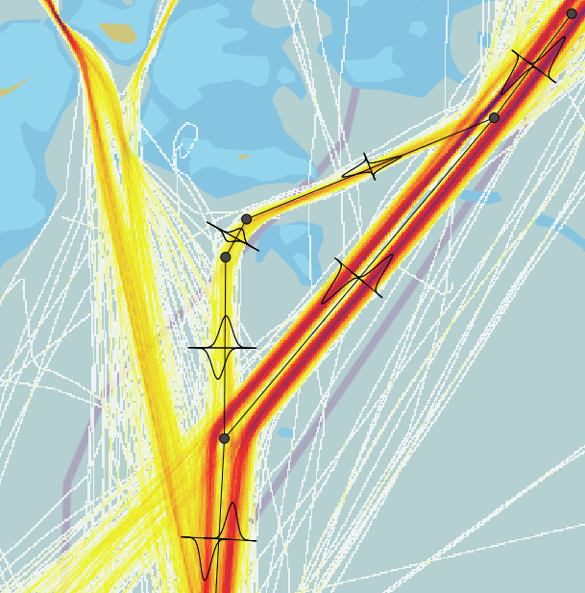

Example of impacts when rerouting shipping in SWC area using AIS risk management tool IWRAP:
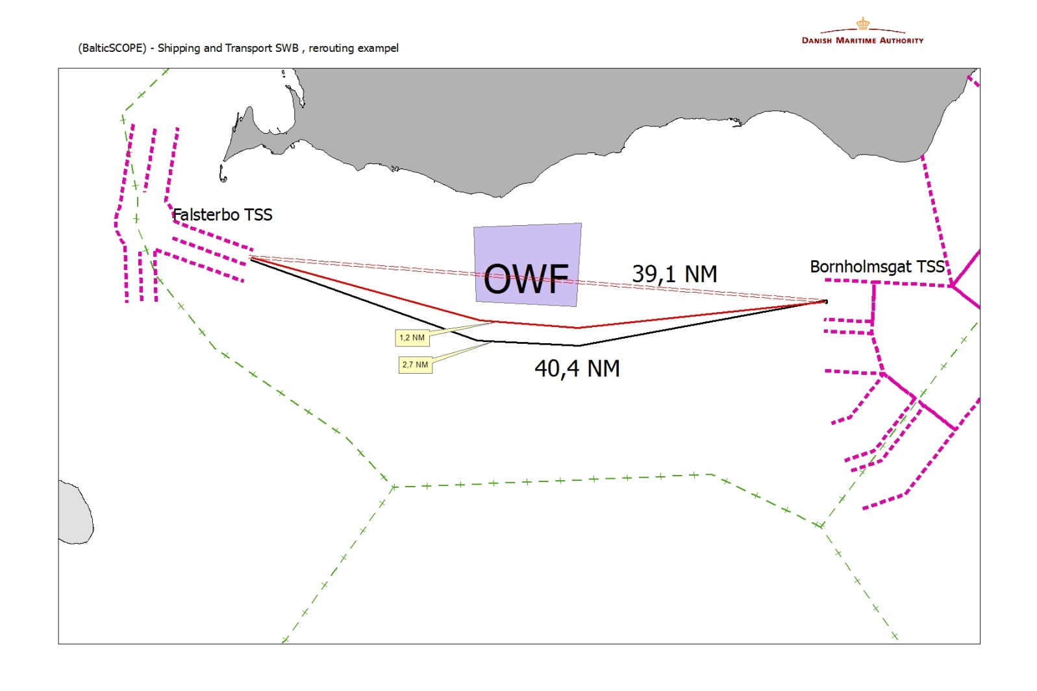
3 models:
a) Today’s situation
b) 1.2 nm to the northern route
c) 2.7 nm to the northern route

Traffic:
Approx. 6,300 westbound ships
Approx. 8,400 eastbound ships
A total of approx. 14,700 ships east-west

 | [Years between incidents]
 | Today | 1.2 nm | 2.7 nm
Ship collisions | 35.6 | 34.7 | 34.3
Collisions with wind farms | - | 64.7 | 85.6
Route extension |  | 2.5% | 4.4%

The probability of ship collisions increases somewhat (3.5%) due to the increased sailing time and the extra turn.
Here, the distance between the wind farm and the uttermost most should be at least 2 nm.
Crossing ferry routes are not included since the number of crossings is the same – however, in other places.

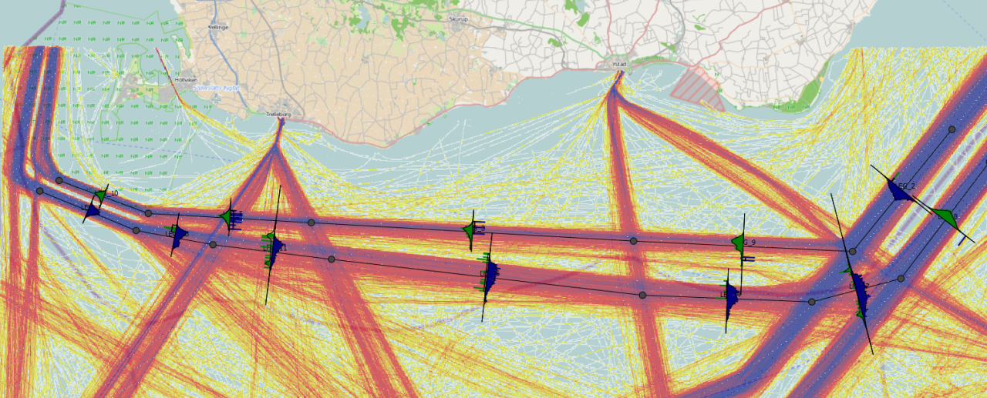

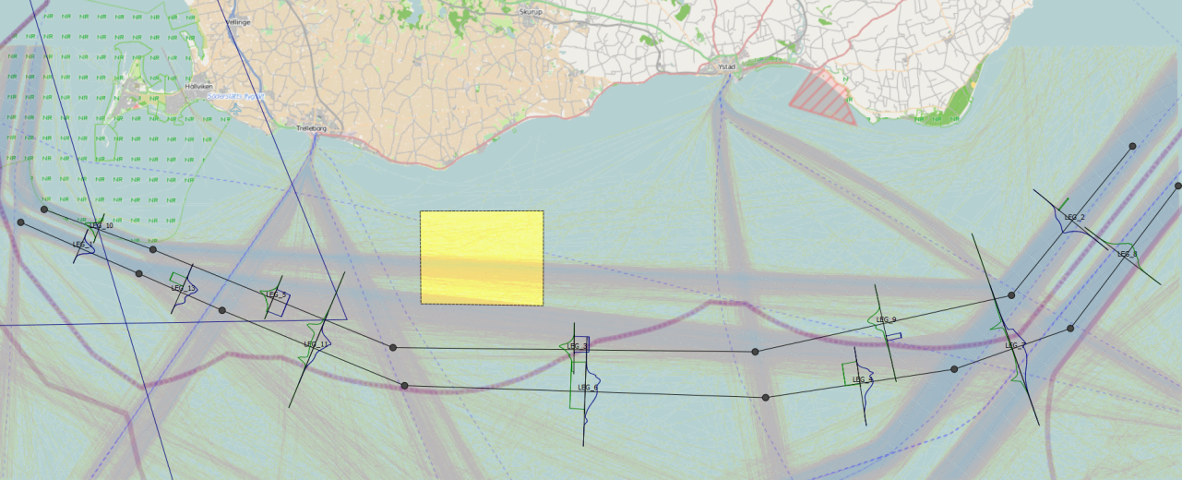

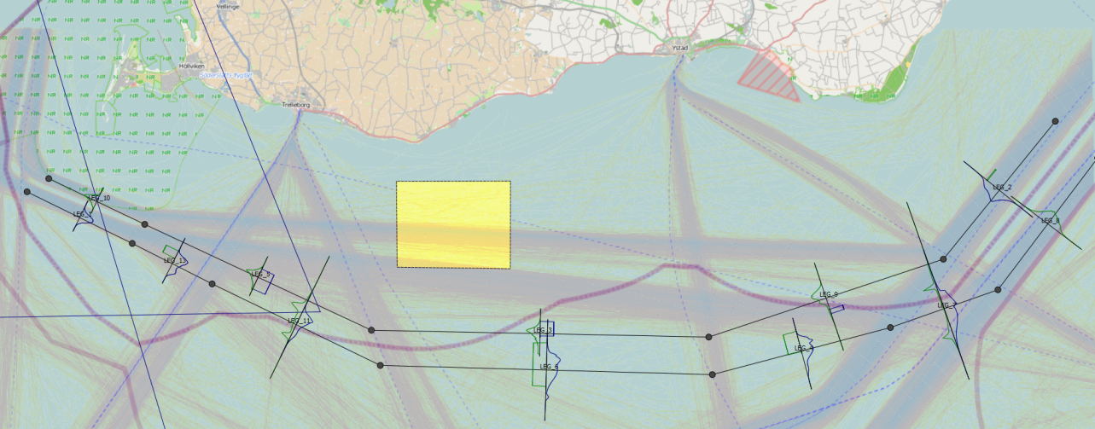

Motive for/discussion on including this topic/sector in the project

We are of the opinion that this topic should be prioritized for the simple reason that shipping, and especially future planning of shipping, is a major issue of importance to the entire Baltic region. All of the parties involved have an interest in protecting and optimizing the sea area, and this can be achieved only through cooperation and a common understanding of the topic.
By prioritizing this topic, we will get an opportunity to improve already established transboundary networks and make new ones. There will be a need for multilateral as well as bilateral thematic meetings in order to make common guidelines on safety of shipping. This will help us take transboundary issues about shipping into account.
Whether or not we should divide the topic into areas of interest to the different countries, or whether all the countries involved should work on the same area is up for discussion. We would like to pursue the aim of achieving coherence and consistency between the different national approaches to the topic.

